IRC Components quickshifter uses a "Strain Gauge" style sensor that is IP65 rated with quick-disconnect plug. We have put an enormous amount of energy in the form of time, technology and knowledge to create a reliable performance-oriented product. This product is encouraged for use on a closed circuit only, is not homologated for road use. IRC is not liable for any injury or damage to the operator, vehicle, or third parties from the use of this product. MADE IN ITALY

DISCLAIMERS

- System setup must always be done when bike is at complete halt and is parked on stands.
A wrong setting could affect, partially or fully, the system’s effectiveness, ultimately damaging the gearbox.
- System setting is the responsibility of the user and not of the manufacturer. While fixing sensors, take extra caution to not damage while screwing and unscrewing the bike. It is a delicate product.
- The use of this product is at the total discretion of the private parties.

- Each system modification, both of hardware and software, as well as harness or single components, could affect the system functionality. It can do potential damage or cause injury to the user, vehicle, or to third parts and this will negate the product warranty.
- Installation must be done carefully It is mandatory that you follow instructions provided in the manual book. After installation it is highly recommended that you do proper test of the product before riding on.
- Installation is an extremely crucial setup for system efficiency. Be sure it is done by competent and specialized mechanic.


WARNING

Our blipper provides an additional throttle % when you need to downshifting. If the engine revs are high, near the red line, the system will provide this acceleration but the bike ECU will cut it to avoid the over revving with engine damage. Result is that the gear could be not engaged or not properly engaged. We suggest don’t pass the 80% of max engine revs when you start the downshifting.
Blipper works only at 0% throttle. Any other opening % could cause bike limp mode.
Engine maps will affect blipper behavior. We suggest to always use racing map, DO NOT USE BLIPPER IN RAIN MAP

1. CONNECTIONS

Please following the following steps to install Blipper in your LEGEND CARS:
  - Fix the Main Boards on the frame
Under rear seat, in an accessible position.
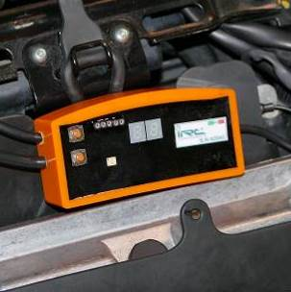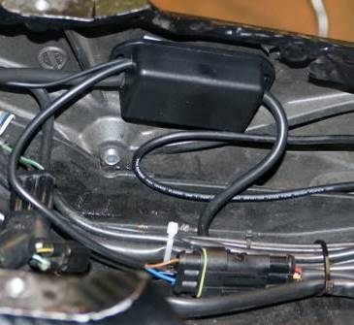

  - Ground Wire Connection
Connect eyed Black wire directly to battery ground.

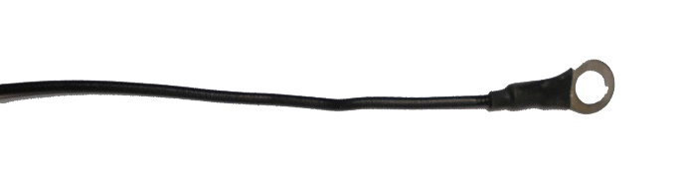

  - Load Cell installation
Sensor has "magic threads" i.e. both right and left. Connect the sensor to the provided shiftrod. Cut it if necessary. Tight the nuts and the eventual grubs to avoid disconnections and loss of functionality due to vibrations.
Install sensor and rod with uniball links on both ends, most bikes have uniballs stock, check that the shiftrod does not rub or touch anything. Put sensor far from very hot parts. Make sure wire has a slight bend/loop so it does not tighten up and pull at the sensor during up or down shift. Warranty doesn't cover ripped out wires.

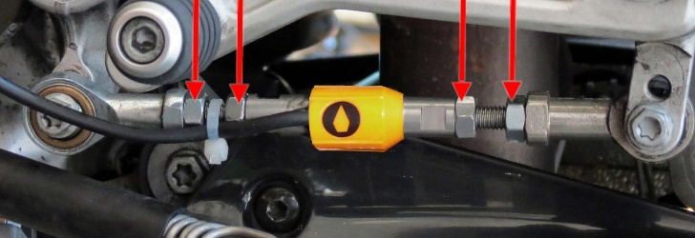

To adjust sensor positioning, act on the proper planes on it. Sensor failure could occur if acting on the cover.
WARNING

  - Coils connector installation
Take the Upkit harness:

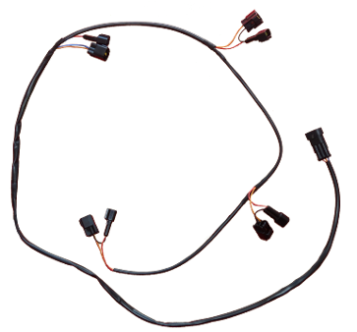

Take the “COIL” bypass
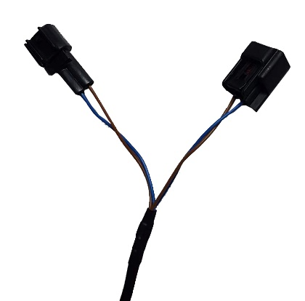
Connect them as per picture below:
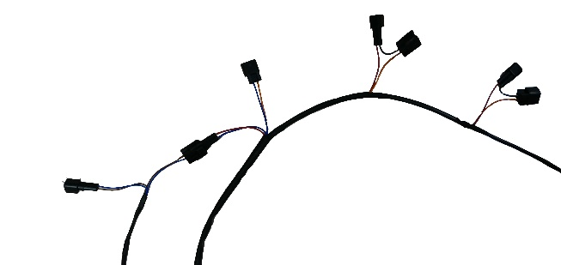


Be careful to connect male and female as per below picture.
WARNING
Female
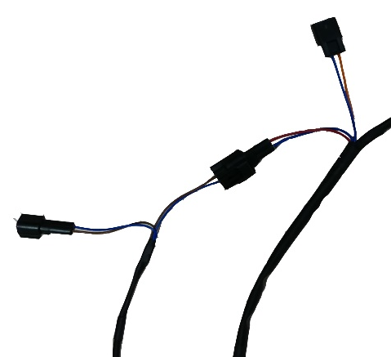
Male

Locate the bike coils and connectors:
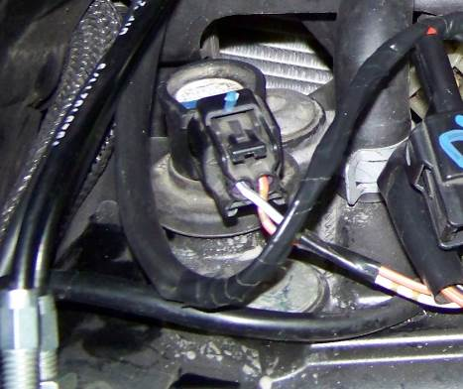
Unplug connectors and put in the between the above bypasses. No matter the order.
FEMALE plugs must be connected to the coils, MALE plugs to the OEM plugs.
Now connect the Upkit Harness “coils” Wire to the black box wire
Black Box
Coils
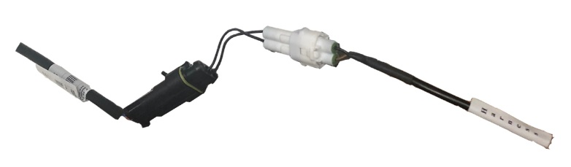

  - APS CONNECTORS
Connect the male/female 4 ways BLACK connectors to the male/female connectors of the APS. Be careful to connect them to twistgrip wire side, not to the throttle body one.
YES
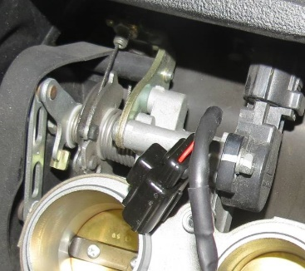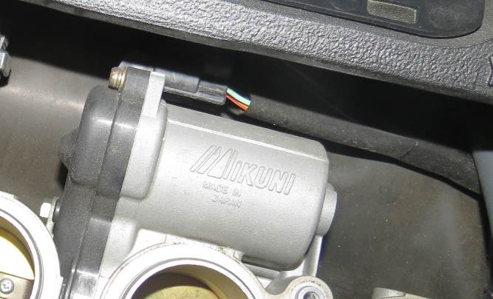
NO

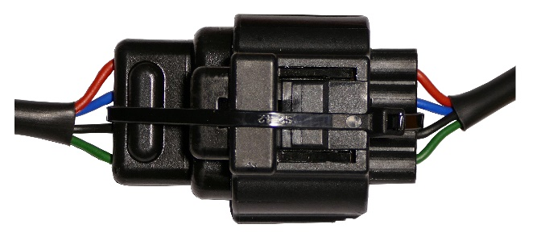

Check the tongues of the connectors are locked. Eventually use a hose clamp or plastic strip to better fix the 2 connectors
WARNING

  - Gear Sensor Connection.
Take the Gear harness (“GEAR” LABELED),
Locate the Gearshift connector on the bike.
Unplug connectors and put in the between the GEAR bypass.
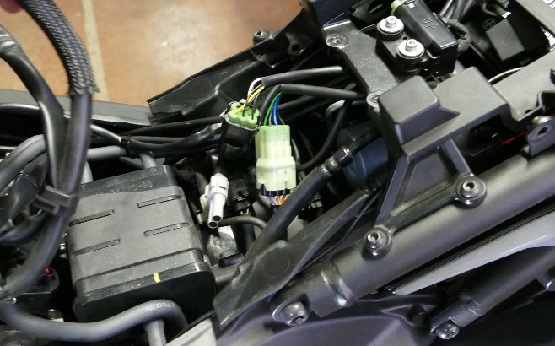

2.DISPLAY

At key on, the system will be powered and the ECU makes a general check. I passed, the display will show the firmware Version.
Do not start any process, setting or action on sensor until the above routine is completed.
In some bikes the “key on” is not sufficient to maintain the unit powered but the engine must run.
When the pre load threshold has passed (par. 3.4 and 3.7), the display will show "--" . In case of failure, the display will show an "E" followed by a number. Give this code to the assistant.

3.SETTING

To set up initial program press both the buttons to enter into the system. Push lower button to scroll the menus forward.
Push the upper one to scroll the menus backwards. Press and maintain the lower button to enter into the various menus. However, to exit from the menu and undermenues press upper or both buttons. System will go out of programming session if no button is pushed except the “r” menu. Also during programming, the quickshifter is disabled.

WARNING: Act only on the following setup options.

  - Signal time programming "t".
If upshift timing will be managed by original ECU or any other module able to manage the upshifting, set “t” at the maximum allowed value. Otherwise the cut time can be adjusted within 20÷99ms. Default is “60”ms.
  - Mimimum rpm "rL".
The “Blip” and “Upshift” will not work below 3,000rpm. Above this limit the timing of the blipper is automatically set in function of customer’s choice. “rL” are the lower rpm limit level. Default is “03”.
  - Downshift timing "SL".
Set the desired timing of the “blip” at “rL” rpm (see par. 3.2).
Default is “50”.
  - Upshift Pre Load adjustment "L".
The default setting is set at "14" and it can be customized according to the need. Keep the ignition on and engine off to try to select the upper gear. Shift lever should move through the spring load in gearbox until gear resistance is felt. The panel LED will display "--" for a while. If this happens too early or too late, then consequently change the preload set.
Default is “14”.

A too high preload could affect the gearbox reliability and makes the shifting “harsh”. A too low preload could cause unpredicted up/downshifting signal.
cuts of the power for a while. An unpredicted downshifting can be dangerous
WARNING
because it “push” the bike ahead so properly adjust this parameter.

  - Actual Load displaying "S".
To read the value of actual applied load select this menu. This feature is also useful for preload adjustments and to check gearbox wear. A too high preload could affect the gearbox reliability.
    - Max Load displaying "--".

At this point, pressing and holding the lower button, the display will show blinking "--" for about 10s. Afterwards it will show the max load value registered in this period. This feature is useful for preload adjustment and for gearbox reliability and maintenance.
  - Downshift Timing "tS".
Set the “Blip” timing within 20÷98ms at 8,000 rpm. Default 98ms. The blip timing at 12,500rpm will be 70ms more than this value. In the between the CPU will interpolate the value. We suggest timings between 98 and 80ms. A too long timing allows gear in but then you’ll feel the bike pushing a while. A too short timing doesn’t allow a proper downshift. We suggest to start with high value and reduce it during the tests on road.
Default is “85”.
  - Downshift Pre Load adjustment "LS".
The default setting is set at "12" and it can be customized according to the need. Shift lever should move through the spring load in gearbox until gear resistance is felt. The panel LED will display "--" for a while. If this happens too early or too late, then consequently change the preload set.
Default is “13”.
  - Pushing/Pulling"CE".
Referring to the upshifting, "C" Pushing, "E" Pulling. To properly set this parameter, engage the 2nd gear and try to put the 3rd. Look at the shiftrod: Is it compressing (C: Push) or extending (E: Pull)?
OEM rearsets require “C”.
  - Normally Open/Closed circuit "OC".
"O": commonly open circuit, default value for OEM quickshifters and for most all additional quickshifter module,
"C": commonly closed circuit, for direct cut of coils (UPKIT) or for Power Commander V and some others.
If OEM bike has the upshifter, or if another additional upshift module is used, set it to “O”, otherwise set it to “C”.
Default “C”
  - Increase of blipping timing in 3rd-2nd and 2nd-1st gears downshifting "1A".
Sometimes the lower gears need a higher blippping timing to be properly engaged. 1A is the Increasing timing in 10 milliseconds. 01 means 10milliseconds. Default is “00”.

  - Smoothness "rr"
If OEM bike has the upshifter, or if another additional upshift module is used, set it to “00”, otherwise, higher values mean increase in smoothness. Initially set the ideal upshift rpm. Visualization: /1000.
Default is “02”.

  - Model bike "tt"
Type of firwmare. Don’t change it. If accidentally changed, set “05”

4. QUICK PRESETTING SUGGESTIONS

The system is provided fully working. Just properly set “CE” (par. 3.8) to immediately enjoy the blipping. However all parameters are set in safety way. Every rider must properly adapt the system to own riding mode.
These are some suggestions:

  - Preloads setting: Give power, don't start engine, don't touch the lever, enter in the menu, go to "S" and check that you read "00" or oscillating "01", not more. Then put 3rd gear and try to push the pedal in the upshifting way till you just “feel” the gears load, not till the upper gear enter. You should read values between "08" and "17". Set this value in “L”. Now try to push the pedal in the downshifting way till you just “feel” the gears load, not till the lower gear enter. You should read values between "08" and "17". Set this value in “LS”. LS should be around L. Difference mustn’t be higher than 2Kgs.

  - Blipping timings setting: concentrate on blipping in gears above 3rd and revvs above 10,000rpm. Is the bike “pushing” you after the downshifting? If yes, reduce “tS”. Is the downshifting “harsh”? Increase “tS”.
After setting the above, now concentrate on blipping in gears above 3rd and revvs around 5,000rpm. Is the bike “pushing” you after the downshifting? If yes, reduce “SL”. Is the downshifting “harsh”? Increase “SL”.

Now check the downshifting in 3-2 and 2-1 gears. Is the downshifting “harsh”? Increase “1A”.

5. TROUBLESHOOTING

  - Bike doesn’t start
Check upkit harness to the coil is well installed as per 4.2.
Check “OC” set in C.
Check ground wire on battery ground, not to the frame.
Check you don’t have “E1” on the display. If yes, contact your dealer.
Check the sensor: Tight the nuts and the eventual grubs to avoid disconnections and loss of functionality due to vibrations as per Par.1
If a LIPO or any other lightweight battery is used, ckeck it eventually replace it.
  - System continuosly cut or blipping even if the foot isn’t acting on the pedal:
Check ground wire on battery ground, not to the frame.
Check you don’t have “E1” on the display. If yes, contact your dealer.
Check the sensor: Tight the nuts and the eventual grubs to avoid disconnections and loss of functionality due to vibrations as per Par.1
If a LIPO or any other lightweight battery is used, ckeck it eventually replace it.
  - Blipper works, upshifting no:
Check “CE according to above par. 3.8.
Check ground wire on battery ground, not to the frame.
Check that when upshifting the display will show "- -" for a while and that you can hear a "click". If no, properly set "L” according to the above 5.1.
Check you don’t have “E1” on the display. If yes, contact your dealer.
Check the sensor: Tight the nuts and the eventual grubs to avoid disconnections and loss of functionality due to vibrations as per Par.1
If a LIPO or any other lightweight battery is used, ckeck it eventually replace it.
Check the “upkit” harness is well installed according to par. 4.3.
  - Upshift works, blipper no:
Check “CE according to above par. 3.8.
Check ground wire on battery ground, not to the frame.
Check that when downshifting the display will show "- -" for a while and that you can hear a "click". If no, properly set "LS” according to the above 5.1.
Check you don’t have “E1” on the display. If yes, contact your dealer.
Check the sensor: Tight the nuts and the eventual grubs to avoid disconnections and loss of functionality due to vibrations as per Par.1
If a LIPO or any other lightweight battery is used, ckeck it eventually replace it.
  - System works in reverse manner:
Check “CE according to above par. 3.8.
  - After blipping, especially at higher rpm, bike goes to limp mode
Check you are connected to APS not to TPS i.e. connect to the first connector you can, following the wires from the throttlegrip. Par 4.3
Reduce “SL” and “tS”.

  - Gears aren’t fully engaged during Upshifting or go out after a while:
Increase “t”.
Check “L”, according to above 5.1. Eventually increase/reduce it a couple of points and test.
  - Gears aren’t fully engaged during Blipping or go out after a while:
Increase “SL” and “tS”.
Check “LS” according to above 5.1. Eventually increase/reduce it a couple of points and test.
  - During blipping bike push ahead.
If at higher rpm (above 8,000rpm) Reduce “tS”.
If at lower rpm, reduce “SL”.

6. WORKING CONDITIONS

11÷17.5V; -20°C÷ +60°C

Enjoy your choice.

For any questions or troubleshooting queries, please contact us at:

tech-support@irccomponents.it • Ph. (+39) 010 8938654

